Assignment 3: API Spec
CS 493: Cloud Application Development
Fall 2020
Oregon State University

Create a Boat
View a Boat
Delete a Boat
Create a Load
View a load
View all loads
Delete a Load
Managing loads
View all loads for a given boat

DATA Model:

As mentioned on Piazza, the relationship between Boats and Loads is one-to-many:

- A boat can have many loads.
- A load is can be on one boat at most.

Create a Boat
Allows you to create a new boat.
POST /boats

Request

Request Parameters
None

Request Body
Required

Request Body Format
JSON

Request JSON Attributes
Name | Type | Description | Required?
name | String | The name of the boat. | Yes
type | String | The type of the boat. E.g., Sailboat, Catamaran, etc. | Yes
length | Integer | Length of the boat in feet. | Yes
loads | String | Id of boat entity | No

Request Body Example
{
"name": "Sea Witch", #The name of the boat, a string
"type":"Catamaran", #The type of boat, catamaran etc. a string
"length":28, #The length of the boat
}

Response

Response Body Format
JSON

Response Statuses
Outcome | Status Code | Notes
Success | 201 Created
Failure | 400 Bad Request | If the request is missing any of the 3 required attributes, the boat must not be created, and 400 status code must be returned.  You don’t need to validate the values of the attributes and can assume that if the request contains any of the listed attributes, then that attribute’s value is valid.  You can also assume that the request will not contain any extraneous attribute (i.e., the request JSON will never contain any attribute other than the ones that are listed).

Response Examples
- Datastore will automatically generate an ID and store it with the entity being created. This value needs to be sent in the response body as shown in the example.
- The self attribute will contain the live link to the REST resource corresponding to this boat. In other words, this is the URL to get this newly created boat. You must not store the self attribute in Datastore

Success
Status: 201 Created

{
"id": "abc123",
"name": "Sea Witch",
"type": "Catamaran",
"length": 28,
"self": "https://<your-app>/boats/abc123"
}

Failure
Status: 400 Bad Request

{
"Error": "The request object is missing at least one of the required attributes"
}

View a Boat
Allows you to view an existing boat
GET /boats/:boat_id

Request

Request Parameters
Name | Type | Description | Required?
boat_id | String | ID of the boat | Yes

Request Body
None

Response

Response Body Format
JSON

Response Statuses
Outcome | Status Code | Notes
Success | 200 OK
Failure | 404 Not Found | No boat with this boat_id exists

Response Examples

Success
Status: 200 OK

{
"id": "abc123",
"name": "Sea Witch",
"type": "Catamaran",
"length": 28,
"loads":[
{"id":"123abc",
"self":"https://appspot.com/loads/123abc"},
{"id":"456",
"self":"https://appspot.com/loads/456"}
], # This embedded list does NOT need to paginate.

"self": "https://<your-app>/boats/abc123"
}

Failure
Status: 404 Not Found

{
"Error": "No boat with this boat_id exists"
}

View all Boats
List all the boats with pagination. It should return 3 boats per page. There must be a 'next' link to get the next page of results, unless there are no more pages of result (i.e., the last page of results shouldn't have the 'next' link).
GET /boats

Request

Request Parameters
None

Request Body
None

Response

Response Body Format
JSON

Response Statuses
Outcome | Status Code | Notes
Success | 200 OK

Response Examples

Success
Status: 200 OK
[
{
"id": "abc123",
"name": "Sea Witch",
"type": "Catamaran",
"length": 28,
"self": https://<your-app>/boats/abc123
},
{
"id": "def456",
"name": "Adventure",
"type": "Sailboat",
"length": 50,
"self": "https://<your-app>/boats/def456"
},
{
"id": "xyz123",
"name": "Hocus Pocus",
"type": "Sailboat",
"length": 100,
"self": "https://<your-app>/boats/xyz123"
}
]
“next”:"http://localhost:8080/loads?cursor=Ci4SKGoTc35icnV0b25jbG9hZGVkYm9hdHIRCxIETG9hZBiAgIC4iuKCCQwYACAA"

Delete a Boat
Allows you to delete a boat. Deleting a boat will unload any loads that were loaded on to it.
DELETE /boats/:boat_id

Request

Request Parameters
None

Request Body
None

Response
No body

Response Body Format
Success: No body
Failure: JSON

Response Statuses
Outcome | Status Code | Notes
Success | 204 No Content
Failure | 404 Not Found | No boat with this boat_id exists

Response Examples

Success
Status: 204 No Content

Failure
Status: 404 Not Found

{
"Error": "No boat with this boat_id exists"
}

Create a Load
Allows you to create a new boat.
POST /loads

Request

Request Parameters
None

Request Body
Required

Request Body Format
JSON

Request JSON Attributes
Name | Type | Description | Required?
name | String | The name of the boat. | Yes
type | String | The type of the boat. E.g., Sailboat, Catamaran, etc. | Yes
length | Integer | Length of the boat in feet. | Yes
loads | String | Id of boat entity | No

Request Body Example
{
“weight”: 5,
“carrier”:”id”,
“content”:”LEGO Blocks”,
“delivery_date”:”1/18/2020”
}

Response

Response Body Format
JSON

Response Statuses
Outcome | Status Code | Notes
Success | 201 Created
Failure | 400 Bad Request | If the request is missing any of the 3 required attributes, the boat must not be created, and 400 status code must be returned.  You don’t need to validate the values of the attributes and can assume that if the request contains any of the listed attributes, then that attribute’s value is valid.  You can also assume that the request will not contain any extraneous attribute (i.e., the request JSON will never contain any attribute other than the ones that are listed).

Response Examples
- Datastore will automatically generate an ID and store it with the entity being created. This value needs to be sent in the response body as shown in the example.
- The self attribute will contain the live link to the REST resource corresponding to this boat. In other words, this is the URL to get this newly created boat. You must not store the self attribute in Datastore

Success
Status: 201 Created

{ "id":"123abc", # automatically generated by the Datastore
"weight": 5, #The weight of the load
"carrier":{
"id": abc123,
"name": "Sea Witch",
"self": "https://appspot.com/boats/abc123"
}, #The boat carrying the load
"content":"LEGO Blocks",
"delivery_date": "10/18/2020" #The date the load is to be delivered
"self":"https://appspot.com/loads/123abc"
}

Failure
Status: 400 Bad Request

{
"Error": "The request object is missing at least one of the required attributes"
}

View a load
View a load.
GET /loads/:load_id

Request

Request Parameters
Name | Type | Description | Required?
load_id | String | ID of the slip | Yes

Request Body
None

Response

Response Body Format
JSON

Response Statuses
Outcome | Status Code | Notes
Success | 200 OK
Failure | 404 Not Found | No slip with this slip_id exists

Response Examples

Success
Status: 200 OK

{ "id":"123abc", # automatically generated by the Datastore
"weight": 5, #The weight of the load
"carrier":{
"id": abc123,
"name": "Sea Witch",
"self": "https://appspot.com/boats/abc123"
}, #The boat carrying the load
"content":"LEGO Blocks",
"delivery_date": "10/18/2020" #The date the load is to be delivered
"self":"https://appspot.com/loads/123abc"
}

Failure
Status: 404 Not Found

{
"Error": "No slip with this slip_id exists"
}

View all loads
View all loads. It should implement pagination similar to view all boats, i.e., 3 loads per page and a 'next' link
GET /loads

Request

Request Parameters
None

Request Body
None

Response

Response Body Format
JSON

Response Statuses
Outcome | Status Code | Notes
Success | 200 OK

Response Examples

Success
Status: 200 OK

[
{
"id":"123abc", # automatically generated by the Datastore
"weight": 5, #The weight of the load
"carrier":{
"id": abc123,
}, #The boat carrying the load
"content":"LEGO Blocks",
"delivery_date": "10/18/2020" #The date the load is to be delivered
"self":"https://appspot.com/loads/123abc"
},
{
"id":"123abc", # automatically generated by the Datastore
"weight": 5, #The weight of the load
"carrier":{
"id": abc123,
}, #The boat carrying the load
"content":"LEGO Blocks",
"delivery_date": "10/18/2020" #The date the load is to be delivered
"self":"https://appspot.com/loads/123abc"
}
]

Delete a Load
Allows you to delete a load. Deleting a load should update the boat that was carrying it.
DELETE /loads/:load_id

Request

Request Parameters
None

Request Body
None

Response
No body

Response Body Format
Success: No body
Failure: JSON

Response Statuses
Outcome | Status Code | Notes
Success | 204 No Content
Failure | 404 Not Found | No load with this load_id exists

Response Examples

Success
Status: 204 No Content

Failure
Status: 404 Not Found

{
"Error": "No load with this load_id exists"
}

Managing loads

It should be possible to assign a load to a boat. If a load is already assigned to one boat and then is assigned to another boat without first being removed, it should return a 403 status code. It should be possible to remove a load from a boat without deleting that load.
PUT /boats/:boat_id/loads/:load_id
Request
Request Parameters
Name | Type | Description | Required?
load_id | String | ID of the load | Yes
Request Body Required
Request Body Format
JSON
Request JSON Attributes
Name | Type | Description | Required?
carrier | String | The name of the boat carrying the load | Yes

Request Body Example
{
"boat_id": abc123
}

Response
Response Body Format
JSON
Response Statuses
Outcome | Status Code | Notes
Success | 200 OK
Failure | 400 Bad Request | If the request is missing any of the 3 required attributes, the load must not be updated, and 400 status code must be returned.  You don’t need to validate the values of the attributes and can assume that if the request contains any of the listed attributes, then that attribute’s value is valid.  You can also assume that the request will not contain any extraneous attribute (i.e., the request JSON will never contain any attribute other than the ones that are listed).
Failure | 404 Not Found | No boat with this boat_id exists
Response Examples
• The self attribute will contain the live link to the REST resource corresponding to this load. You must not store this attribute in Datastore.
Success
Status: 200 OK

{
{ "id":"123abc", # automatically generated by the Datastore
"weight": 5, #The weight of the load
"carrier":{
"id": abc123,
}, #The boat carrying the load
"content":"LEGO Blocks",
"delivery_date": "10/18/2020" #The date the load is to be delivered
"self":"https://appspot.com/loads/123abc"
}}
Failure
Status: 400 Bad Request

{
"Error": "The request object is missing at least one of the required attributes"
}

Status: 404 Not Found

{
"Error": "No slip or boat with this id exists"
}

View all loads for a given boat
~11:40 demo
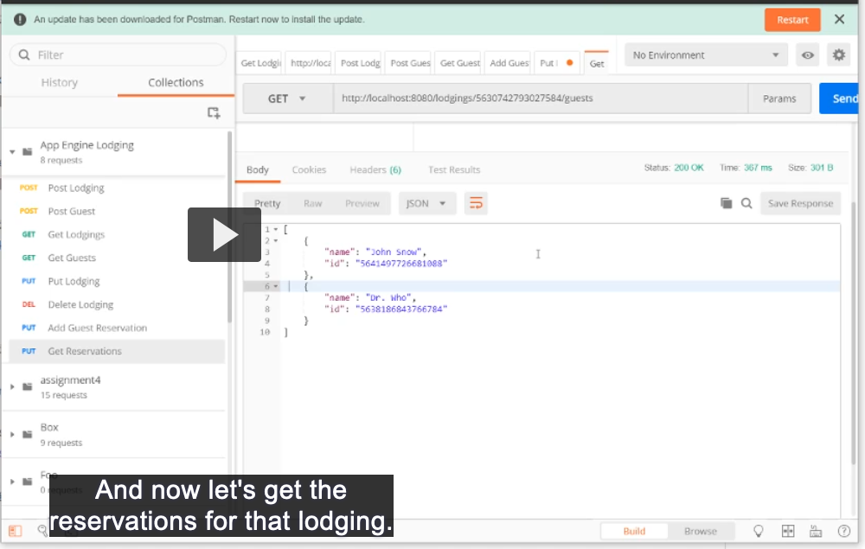

This doesn't require pagination
GET /boats/:boat_id/loads

Request

Request Parameters
Name | Type | Description | Required?
boat_id | String | ID of the load | Yes

Request Body
None

Response

Response Body Format
JSON

Response Statuses
Outcome | Status Code | Notes
Success | 200 OK

Response Examples

Success
Status: 200 OK

[
{
"id":"123abc", # automatically generated by the Datastore
"weight": 5, #The weight of the load
"carrier":{
"id": abc123,
}, #The boat carrying the load
"content":"LEGO Blocks",
"delivery_date": "10/18/2020" #The date the load is to be delivered
"self":"https://appspot.com/loads/123abc"
},
{
"id":"123abc", # automatically generated by the Datastore
"weight": 5, #The weight of the load
"carrier":{
"id": abc123,
}, #The boat carrying the load
"content":"LEGO Blocks",
"delivery_date": "10/18/2020" #The date the load is to be delivered
"self":"https://appspot.com/loads/123abc"
}
]

